# Example Transformation for Secure Tropos (ST) to Business Model and Notation 2.0 (BPMN 2.0) Jan Rehwaldt, University of Tartu

## Asset Model Transformation

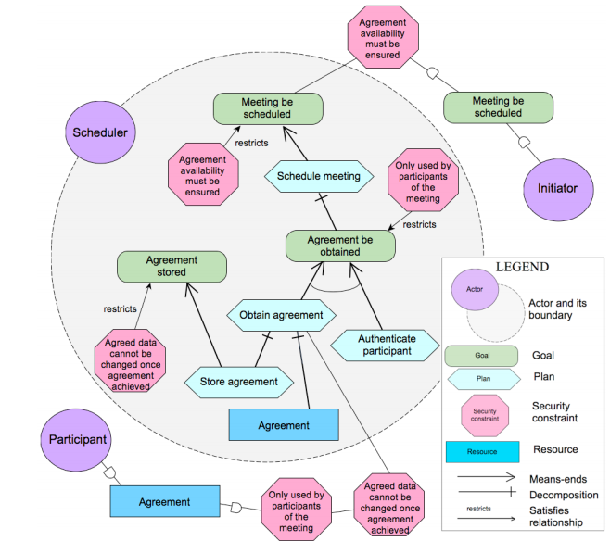

**TR1.** Secure Tropos’ *Actors* are transformed into BPMN’s *Lanes* defining all participants of the visualized system.

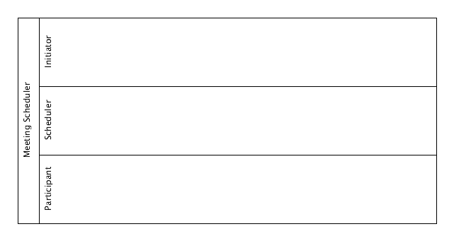

**TR2.** Secure Tropos’ *Plans* are transformed into BPMN’s *Tasks*.

Note: The resulting Event should be located in the Lane of the Actor

1. in which boundaries the Goal is, or,
2. which is the closest to the Goal.

Note: Secure Tropos’ *Decomposition*-Relations are transformed into BPMN’s *Sub-Tasks* with all following *Means-End*-related *Plans* and *Goals* included within this *Sub-Task*.

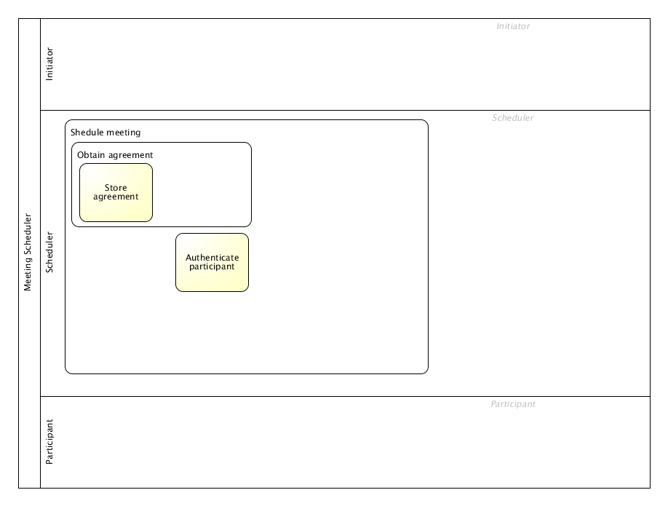

**TR3.** Secure Tropos’ *Goals* are transformed into BPMN’s *(Throwing) Intermediate Events*.

Note: The resulting Event should be located in the Lane of the Actor

1. in which boundaries the Goal is, or,
2. which is the closest to the Goal.

Note: If the *Goal* is connected by a *Decomposition*-Relation with a *Plan* then the resulting *Event* is included in the *Sub-Task* as transformed in TR2.

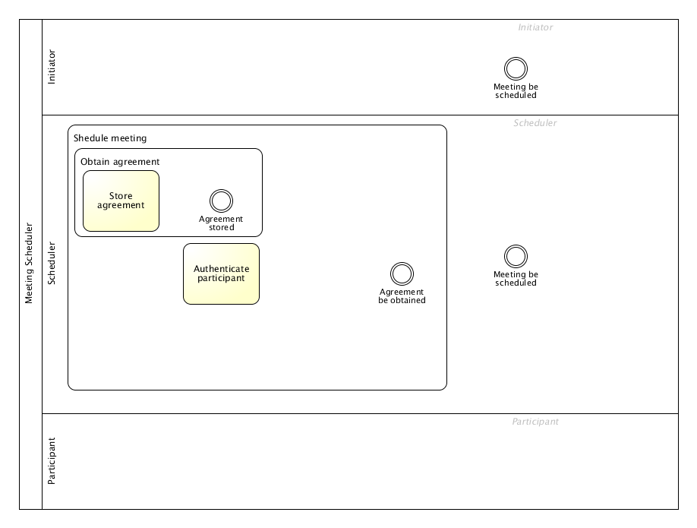

**TR4.** Secure Tropos’ *Resources* are transformed into BPMN’s *Data Objects*.

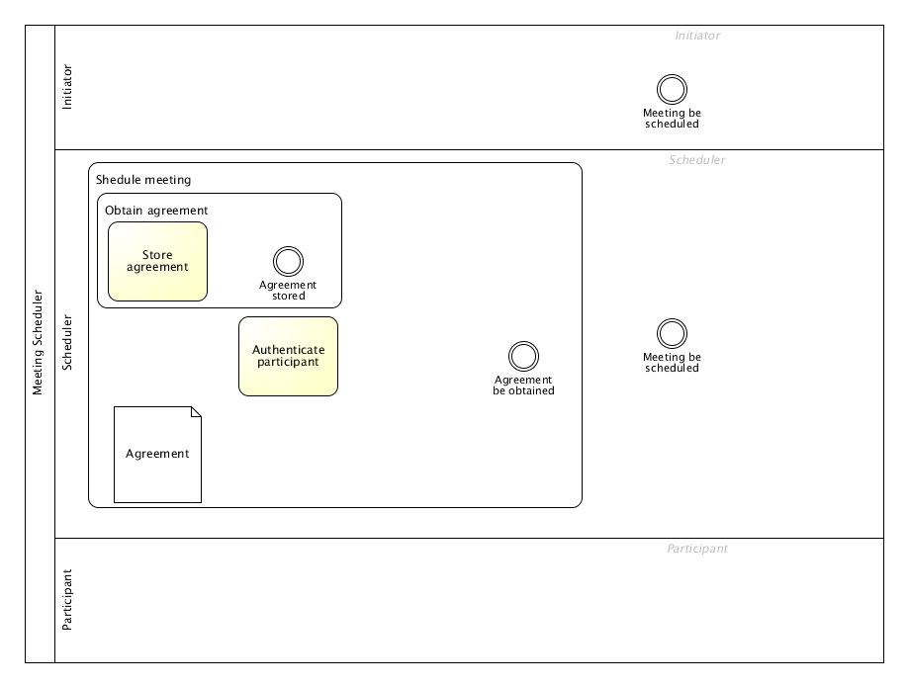

**TR5.** Add a *unidirectional Association*-Relation between Tasks and Data Objects for each *Means-End*-Relation between Plan and Resource.

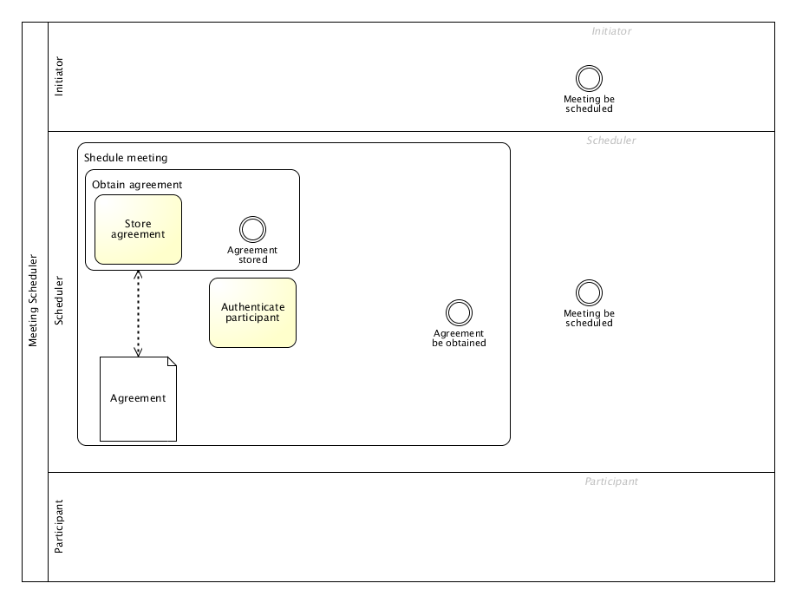

**TR6.** Add a *Sequence Flow* in inverse order between Tasks and Events for Direct *Dependency*-Relations between Plans and Goals and vise versa.

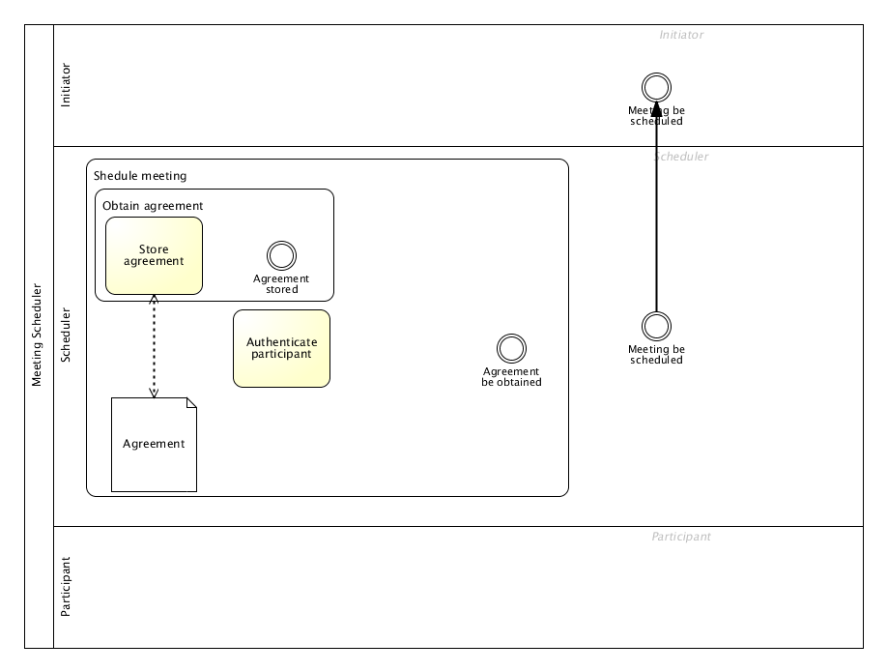

**TR7.** Add a *Sequence Flow* between Tasks and Events for each *Means-End*-Relation between Goals and Plans.

Note: If multiple *Means-End*-Relations go to the same Goal or Plan combine those with an *AND-Gateway*.

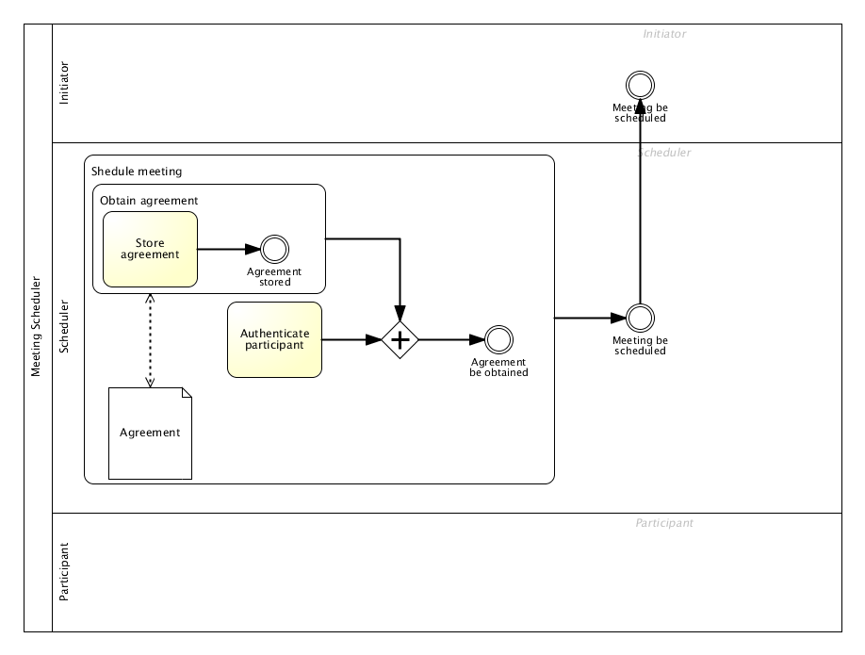

**TR8.** For each Secure Tropos’ Security Constraint add a BPMN’s Annotation to the model associated with the target object as transformed in previous steps.

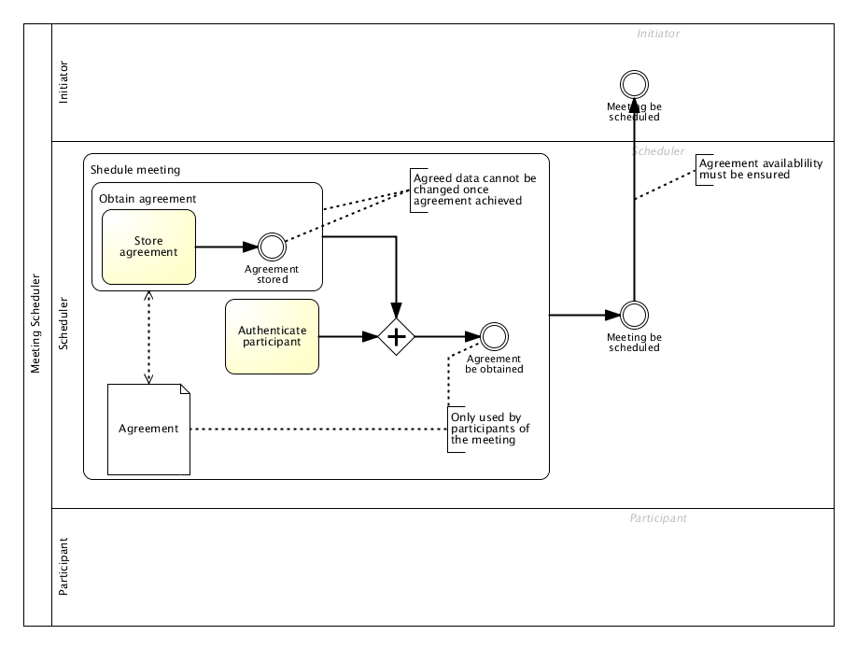

**Result.**

* Most constructs may be successfully transformed
* Security constraints are only preserved as comments
* Some Tasks may be unordered
* Only AND-Gateways and plain Sequence Flow may be generated
* Means-End from Goal / Plan to Goal / Plan may not be successfully transformed as it is unclear whether it should be a Sub-Task or rather an AND-Gateway

## Risk Model Transformation

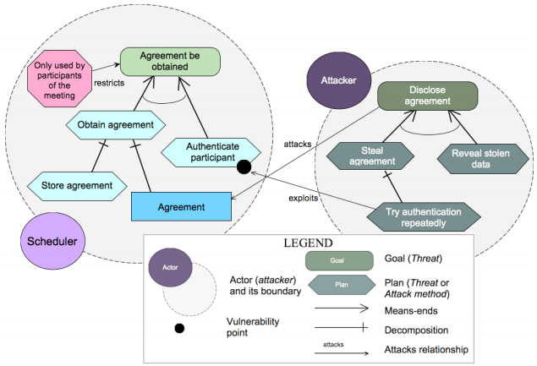

**TR9.** Perform Transformation steps T1-8 for all additional artifacts.

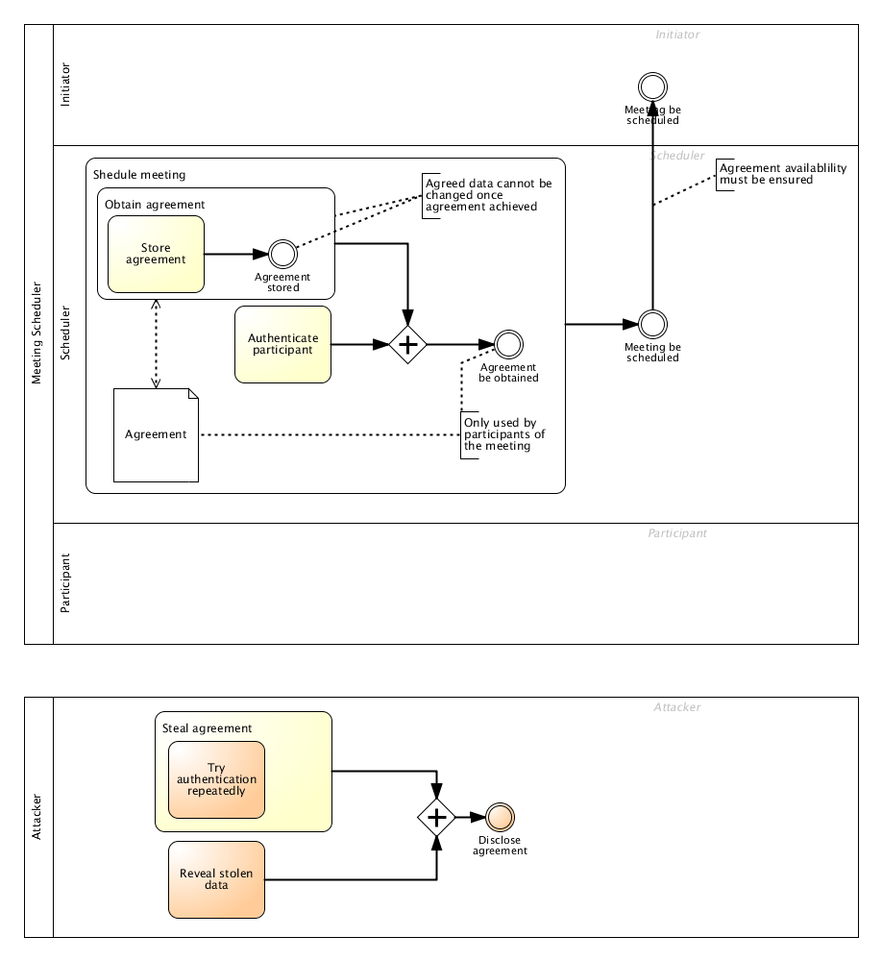

**TR11.** Transform *Attack*-Relation from Goal or Plan to Resource as *unidirectional Association*-Relation.

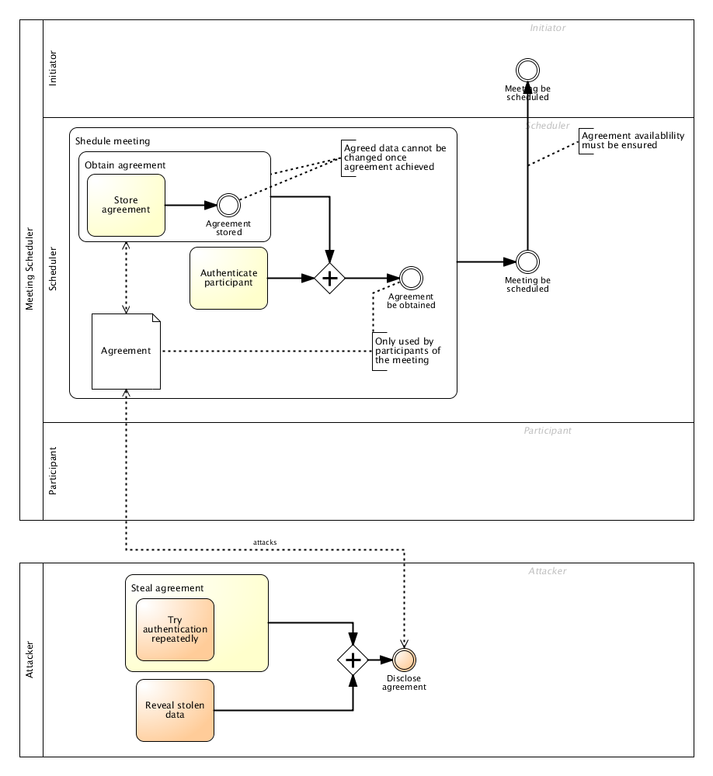

**TR12.** Secure Tropos’ *Exploits*-Relations are transformed into BPMN’s *Message Flow*-Relations.

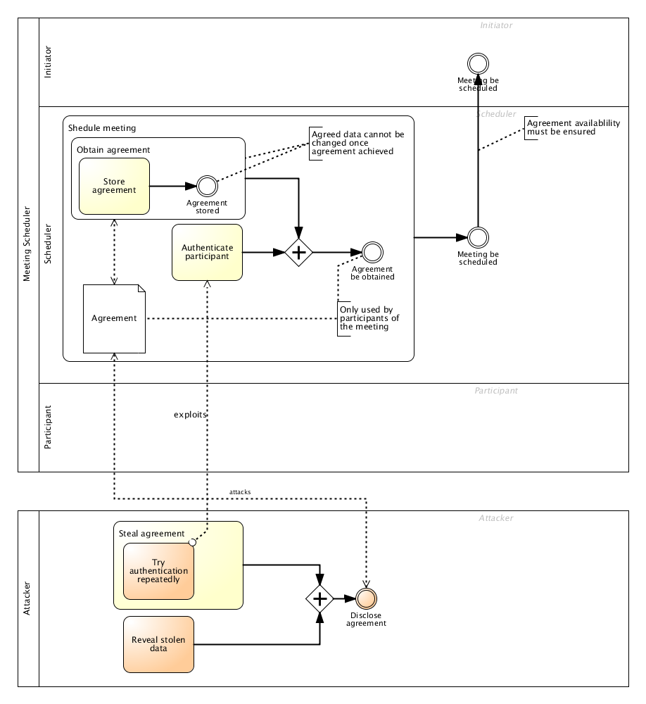

**Result.**

* Vulnerability Points are implicitly identified by target of exploits Message Flow
* Attacker activities and Actors are successfully contributed to the first step's BPMN model

## Risk-Treatment Model Transformation

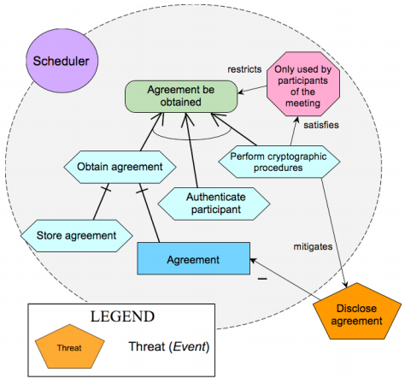

**TR13.** Perform Transformation steps T1-12 for all additional artifacts.

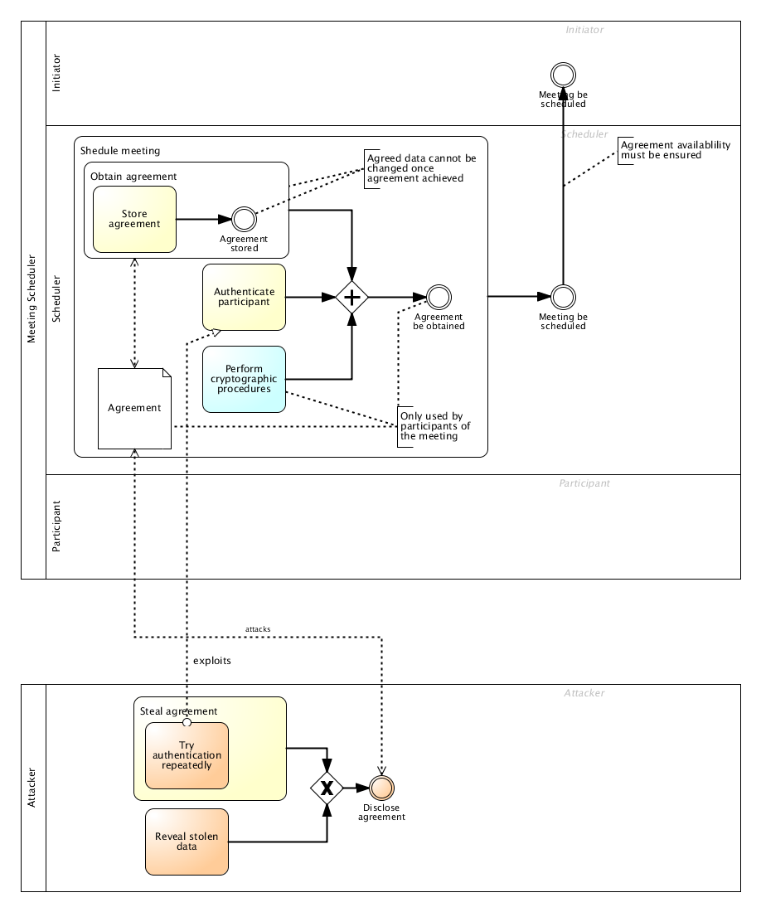

**TR14.** Secure Tropos’ *Mitigates*-Relations from Goal or Plan to Threat are transformed into BPMN’s *Annotations* associated with the source Task or Event.

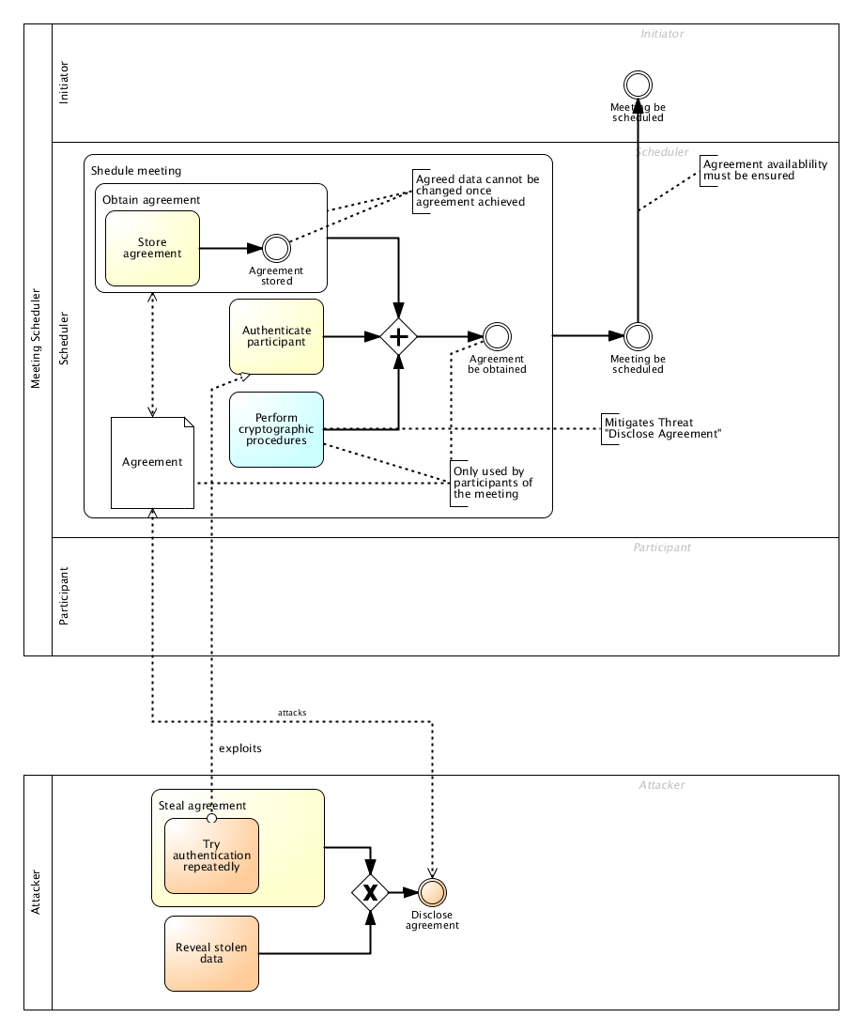

**TR15.** Secure Tropos’ *Impact*-Relations (- / +) from Threat to Resource are transformed into BPMN’s *Annotation* and associated with the Threat’s Attack-Relation (from step TR11) or discarded, if such a relation does not exist.

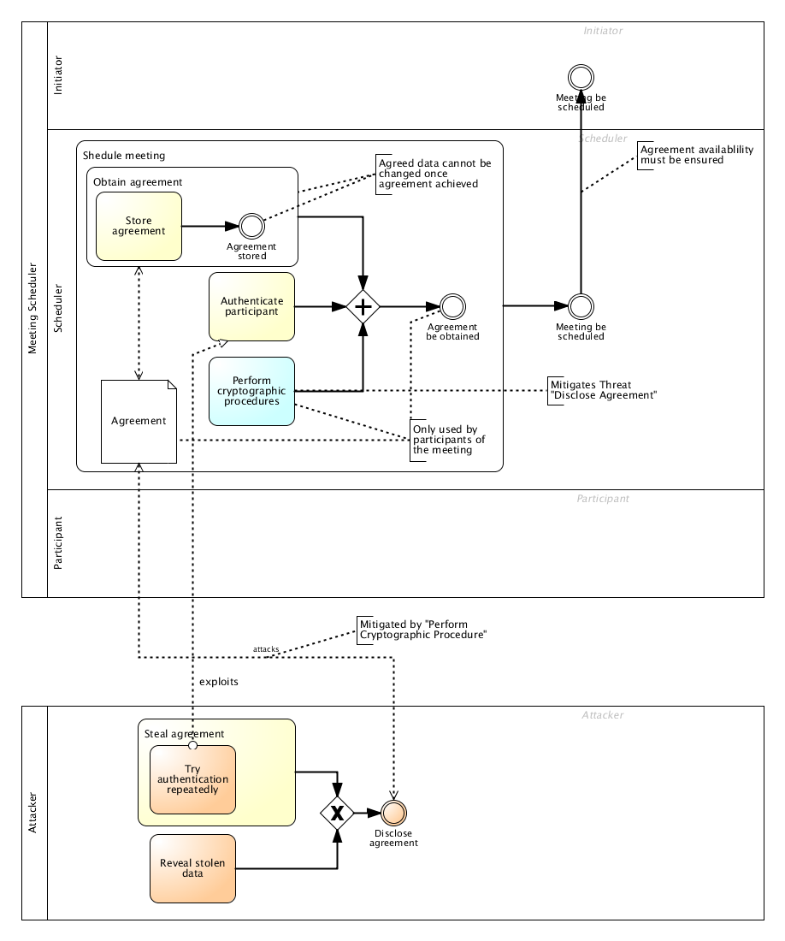

**Result.**

* Security-related constructs mainly transformed as Annotations
* Impact link may become visible when splitting BPMN diagram into pre- and post-Risk Treatment versions

## Finalize & Handwork

**TR16**. Link unlinked Tasks with each other.

**TR17**. Define starting and end points, possibly additional events.

**TR18**. Revise Tasks and Events for specialized types (e.g. Message Event instead of Plain Intermediate Event).

**TR19**. Combine or split Tasks.